
A Reconstructive Surgery Foundation for the Treatment of Cleft Lips and Palates

China 2002 Contact List

Table of Contents

A. Surgeons 2
B. Anesthesia 2
C. Nurses 3
D. Anesthesia/Recovery Room Nurses 4
E. Surgical Assistants 4
F. Administrators/Coordinators 5
G. Dentists 6
H. Prospective/Backup Team 6
I. Other Trip Contacts 7
J. Team Bios 7
Tim Marten 7
Reid and Julie Reid Neilson 8

Surgeons
1 |  | Howard Kotler, MD (USA)  (312) 243-4359 (home)  (312) 606-0672 (office)  (312) 791-2651 (fax)  (312) 400-4957 (page)  hkotl@earthlink.net | 513 N Claremont Ave  Chicago, IL 60612 USA | 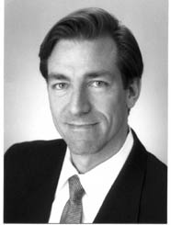
2 |  | Guy Engelmann, MD (USA)  (415) 931-6466 (office)  (415) 225-0217 (cell)  (415) 346-9776 (home)  (415) 346-9787 (fax)  (415) 251-5790 (page)  gengel1999@aol.com | 909 Hyde St #115  San Francisco, CA 94109 USA | 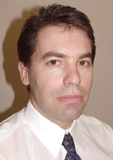
3 |  | Tim Marten, MD (USA)  (415) 677-9838 (office)  (415) 677-9473 (fax)  (415) 207-1759 (page)  (415) 823-4993 (cell)  (415) 362-2253 (home)  tjmarten@martenclinic.com | Marten Clinic of Plastic Surgery  450 Sutter St Suite 826  San Francisco, CA 94108 USA | 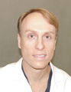
4 |  | Ian Young, MD (Australia)

Anesthesia
5 |  | Peter Mayerhofler, MD (USA)  (415) 931-4126 (voice/fax)  (415) 774-4996 (page)  pmayerhofler@hotmail.com | 1221 Jones St #9E  San Francisco, CA 94109 USA | 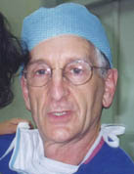
6 |  | Craig Nielsen, MD (USA)  (925) 934-4118 (home)  (925) 370-5340 (work)  (925) 603-4333 (page)  craignielsen@home.com | 3467 Stagecoach Drive  Layfayette, CA 94549 USA | 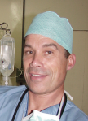
7 |  | Andrew Infosino, MD  (415) 719-2089 (page)  (415) 806-5755 (cell)  (415) 221-0536 (home)  infosino@anesthesia.ucsf.edu |  | 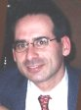
8 |  | Joan Howley, MD  (415) 502-1062 (work)  (415) 719-5025 (page)  (415) 514-0185 (fax)  howleyj@anesthesia.ucsf.edu |  | 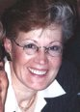
9 |  | Mark Cappello, RN, RNA  (773) 784-0442 (home)  mtcappello@hotmail.com |  | 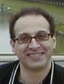

Nurses
10 | Mary Heylin, RN (USA)  (415) 362-2253 (home)  (415) 677-9473 (fax)  (415) 601-7846 (cell)  mcheylin@yahoo.com |  | 155 Jackson St # 1105  San Francisco, CA 94111 USA | 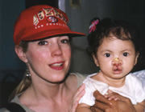
11 | Val Smith-Orr, RN (Australia)  011 61 75 442 2557 (home)  011 61 75 442 2557 (fax)  011 61 75 470 6343 (wk fax)  Val_Smith-Orr@health.qld.gov.au |  | 11 Blackall Range Road  Woombye Queensland 4559  Australia | 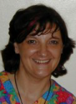

Anesthesia/Recovery Room Nurses
12 | Melanie Chamberlain, RN (Australia)  mchamberlain@yahoo.com.au |  |  | 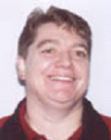
13 | Terry Feltus  011 618 8240 5634 (home)  tafeltus@yahoo.com.au |  | 132 New St  Queenstown  S. Australia 5014 | 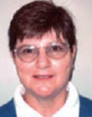
14 | Bernice McLennan  07 5494 2561 (home)  07 5494 2208 (work)  mackie@sun.big.net.au

Surgical Assistants
15 | Julie Neilson, CORT  (415) 586-6613 (home)  jrtn@yahoo.com |  | 58 Brentwood Ave  San Francisco, CA 94127 | 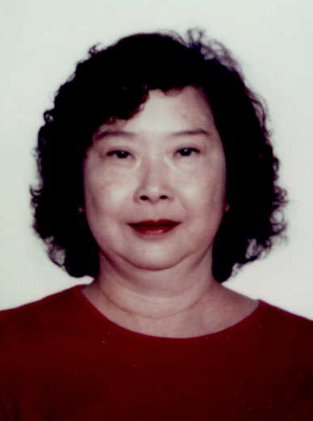
16 | Reid Neilson, CORT  (415) 586-6613 (home)  jrtn@yahoo.com |  | 58 Brentwood Ave  San Francisco, CA 94127 | 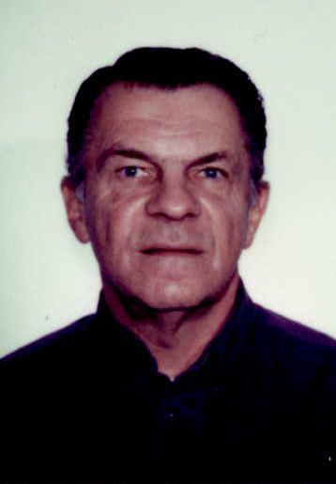
17 | Michelle Li, MD  (415) 831-2917 (home)  (415) 719-5113 (page)  mli@stanfordalumni.org |  |  | 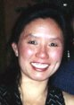
18 | Cheryl Vargus, MD  (937) 291-9992 (home)  (937) 291-9992 (fax)  cherylvargus@earthlink.net |  |  | 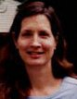

Administrators/Coordinators
19 | Heather Becker  (312) 543-1462 (cell)  hbec@earthlink.net |  | 513 N Claremont  Chicago, IL 60612 | 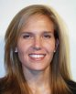
20 | Jim Miller  (415) 397-9797 (home)  (415) 558-6344 (bus)  jim_miller@ci.sf.ca.us |  | 115 Jackson St. #605  San Francisco, CA 94111 | 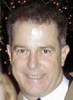
21 | Cam Young (Val’s friend)  07 54 947 926 (home)  07 5475 5000 (work)  hotcamshaft@hotmail.com

Dentists
22 | Jack Chow

Prospective/Backup Team

Anesthesia
- Phil Boysen
- Dixon Wu
- Susan Maloney
- Ian Brown
- Larry Garlington

Nurses
- Erin McIntosh (Val’s friend)

Surgical Assistants
- Roxanne Sheridan
- Christe Boysen (Phil’s daughter OR tech / now in nursing school)?

Administrators/Coordinators
- Craig Harvey (craig@dhcconsulting.com)
- Jaylene Harvey (Jaylene@dhcconsulting.com)

Physicians
- Jack Chow, Jr. (“Jackie Chow” – Jack’s son))

Physicians
- Phil Boysen’s son-in-law (Yale med oncologist/internist)

Other interested parties
- Camilla Einfeldt
- Ellen Nadel
- Linda Yance (prospective rhinoplasty patient) Wants to be considered as lay team member 821-7335
- Daughter of donors Gloria and John Malgarini (RN)

Other Trip Contacts

Travel Agent (USA)
- David Ramos
Siemer and Hand Travel
750 Battery St Suite 300
San Francisco, CA 94111
(415) 788-4000 (x312)
davidr@siemerhand.com

Travel Agent(s) (Australia)
- Geoff Earl
terrace.travel@uq.net.au
- Flight Centre West Lakes
Carlea_Bound.4ix@flightcentre.com

World Effort Foundation, Inc
- Jenny Perrino
Vice President and Secretary
(651) 298-1129 (w)
(612) 298-1299 (h)
79 Western Ave Suite 608
St Paul, MN 55102
jperrino@compuserve.com

Team Bios

Tim Marten
Dr Marten is a Board Certified plastic surgeon and Director of the Marten Clinic of Plastic Surgery in San Francisco. He received his medical degree with honors from the University of California Davis and completed his Plastic Surgery training at the University of Illinois at Chicago Medical Center. Dr Marten has published over thirty scientific articles and plastic surgery textbook chapters and he has received numerous professional, scientific and academic awards for his presentations, lectures and techniques.

Dr Marten has been selected as one of the nations leading medical specialists by both “America’s Top Doctors” and the “Best Doctors In America” and is listed in “American Directory of Who’s Who”, “Who’s Who in the United States”, “Who’s Who in Professional America”, “Marquis Who’s Who”, “Strathmore’s Who’s Who” and “Who’s Who of Executives and Professionals” for his contributions to the field of Plastic Surgery. Dr Marten has also received the University of California Davis Alumni’s Humanitarian Award and is the three time recipient of the American Medical Association’s “Physician’s Recognition Award”.

Dr Marten has been actively involved in charity surgery organizations providing free reconstructive surgery to patients with birth defects of the face in medically under-served parts of the world for over fifteen years. In 1994 he founded Operation Sunrise to expand the scope these activities and improve the services provided to these patients.

Reid and Julie Neilson
Reid received his operating room training in the United States Navy as a navy corpsman. He has worked in the operating room as a surgical assistant/technologist for the last 35 years here in San Francisco, at St Luke's Hospital and Kaiser Hospital.He is a certified operating room technician (CORT).

Juliana received her operating room training at the Queens Medical Center in Honolulu, Hawaii. She has worked in the operating room as a surgical assistant/technologist for the last 35 years in Hawaii at Queens Medical Center and in San Francisco at Kaiser Hospital, The Marten Clinic of Plastic Surgery and Dr. Jerome Kirschbaum, dermatologist. She is a certified operating room technician(CORT).

.

